Designing and Developing a Reinforcement Learning Based Adaptive Recommendation Engine for News and Current Affairs

CHAPTER 1: INTRODUCTION
1.1 Introduction

In today’s hyperconnected digital world, information flows faster than ever before. With just a smartphone and an internet connection, users are exposed to an endless stream of news from online platforms, including digital newspapers, mobile applications, and social media feeds. According to the Reuters Institute for the Study of Journalism Digital News Report (2023), over 70% of global users access news online, with mobile devices being the primary medium [24]. While this accessibility has democratized information, it has also introduced a critical challenge: information overload.
Users are no longer struggling to find news—they are struggling to filter it. The sheer volume of content, ranging from local developments in Lusaka to global geopolitical events, often overwhelms readers. This abundance can lead to cognitive fatigue, reduced engagement, and even exposure to irrelevant or misleading information. Studies by Pew Research Centre highlight that many users feel exhausted by the constant influx of news, with some actively avoiding it due to its overwhelming nature [25].
To manage this complexity, modern digital platforms increasingly rely on recommendation systems. Companies such as Google, Meta, and Netflix have demonstrated the power of personalization in enhancing user engagement by tailoring content to individual preferences [3]–[5]. In the context of news, recommendation systems aim to curate articles based on user interests, browsing history, and interaction patterns, thereby improving relevance and user satisfaction.
Traditional approaches to recommendation—such as collaborative filtering and content-based filtering—have been widely adopted. However, these methods have inherent limitations. They depend heavily on historical user data and often struggle with cold start problems (new users or new content), static assumptions about user preferences, and delayed adaptation to emerging trends [8]. This becomes particularly problematic in the news domain, where timeliness and adaptability are critical. News is not static; it evolves minute by minute. A user who typically reads sports news may suddenly seek updates on elections, economic policies, or global crises. For instance, during major global events such as the COVID-19 pandemic, user interest patterns shifted dramatically and unpredictably. Traditional systems often fail to respond effectively to such rapid changes.
This is where Reinforcement Learning (RL) introduces a transformative opportunity. Unlike static recommendation models, RL enables systems to learn continuously through interaction. By modelling the recommendation process as a sequence of decisions, the system can observe user actions (clicks, reading time, shares), receive feedback in the form of rewards or penalties, and adapt its strategy in real time to maximize user engagement [6]. Research by DeepMind and advancements in adaptive systems have shown that RL-based models can outperform traditional approaches in dynamic environments where user preferences evolve rapidly [7]. Contextual bandit approaches, for example, have demonstrated effectiveness in personalized news recommendation scenarios [10].
In the context of news recommendation, this means moving from a reactive system to a proactive and intelligent system—one that not only understands what users liked in the past but also predicts and adapts to what they need now.
Therefore, this project proposes the design and development of a Reinforcement Learning-based Adaptive News Recommendation Engine. The system aims to deliver personalized, relevant, and timely news content by continuously learning from user behaviour and dynamically adjusting its recommendations. By doing so, it seeks to address the limitations of traditional models and contribute to a more efficient, engaging, and user-centred news consumption experience.
Ultimately, this study is not just about improving recommendation accuracy—it is about reshaping how users interact with information in an era defined by digital overload, ensuring that the right information reaches the right user at the right time [9], [11].

1.2 Problem Statement
Despite the widespread adoption of recommendation systems across digital platforms, many existing news recommendation systems still rely on static or semi-static models that primarily analyse historical user behaviour to generate suggestions. While these systems provide a baseline level of personalization, they face significant limitations when applied to the dynamic and fast-paced nature of news consumption [8].
One of the most critical challenges is the time-sensitive and rapidly evolving nature of news content. News ecosystems are highly volatile, with topics emerging, trending, and becoming obsolete within short timeframes. According to the Reuters Institute for the Study of Journalism Digital News Report (2023), user attention shifts rapidly toward breaking stories, highlighting the need for systems that can adapt in near real-time [24]. However, traditional recommendation approaches often fail to respond quickly to such changes, resulting in outdated or irrelevant content being recommended, thereby reducing user engagement and satisfaction.
Secondly, conventional recommendation systems tend to reinforce historical user preferences, which can inadvertently create filter bubbles. The concept of filter bubbles, popularized by Eli Pariser, describes how algorithms repeatedly expose users to similar viewpoints, limiting their access to diverse perspectives. Empirical studies by the Pew Research Center have shown that algorithm-driven news feeds can contribute to information silos, particularly in political and social contexts [25]. This issue is especially concerning in news systems, where exposure to diverse viewpoints is essential for informed decision-making and civic awareness.
Thirdly, news recommendation systems must address the well-known exploration–exploitation dilemma, a fundamental problem in Reinforcement Learning. The system must strike a balance between:
- Exploitation: recommending familiar content aligned with known user interests
- Exploration: introducing new, diverse, or unexpected content
In the context of news, this balance is crucial. Overemphasis on exploitation leads to repetitive and narrow content delivery, while excessive exploration may reduce relevance and user satisfaction. Research in adaptive systems, including work by DeepMind, demonstrates that systems capable of dynamically balancing this trade-off significantly improve long-term user engagement and learning efficiency [6], [7].
Furthermore, real-world platforms such as Meta and YouTube have faced criticism for recommendation algorithms that amplify repetitive or biased content, sometimes leading to misinformation spread or content polarization. These challenges highlight the broader societal implications of poorly adaptive recommendation systems [9].
Without an adaptive and intelligent learning mechanism, existing news recommendation systems are prone to several shortcomings:
- Failure to capture emerging and short-term user interests
- Delivery of repetitive or overly biased content
- Limited exposure to diverse and globally relevant news topics
- Reduced ability to respond to real-time changes in user behaviour and news trends
These limitations underscore the need for a more advanced approach that goes beyond static modelling techniques.
Therefore, there is a strong need for an intelligent, adaptive recommendation system capable of continuously learning from user interactions, dynamically responding to evolving news trends, and maintaining a balance between relevance and diversity.
This project addresses these challenges by proposing the development of a Reinforcement Learning-based Adaptive News Recommendation Engine. By leveraging continuous feedback and real-time learning, the system aims to enhance personalization, improve adaptability, and promote content diversity, ultimately delivering a more effective and socially responsible news consumption experience [10], [11].

1.3 Aim and Objectives
To design and implement a reinforcement learning-based adaptive recommendation engine for news and current affairs that improves personalization, adaptability, and relevance of recommended content.

1. To analyse the limitations of existing news recommendation techniques in handling dynamic and real-time content.
2. To design and develop a reinforcement learning model that adapts to user interactions and evolving interests in both local and international news.
3. To evaluate the effectiveness of the proposed system in terms of accuracy, user engagement, and diversity of recommended content.

1.4 Research Questions
How can a reinforcement learning-based adaptive recommendation engine improve the personalization and effectiveness of news and current affairs recommendations compared to traditional systems?
1. What are the limitations of existing news recommendation systems in handling dynamic and real-time content?
2. How can reinforcement learning be applied to adapt recommendations based on evolving user interests in local and international news?
3. How effective is the proposed system in improving recommendation accuracy, user engagement, and content diversity?

1.5 Scope and Limitations
This study focuses on the design and development of an adaptive recommendation engine tailored for news and current affairs, with particular emphasis on both local Zambian and international news content. The research explores existing recommendation approaches and examines their suitability within the dynamic context of news delivery. It involves the development of a reinforcement learning model capable of adapting to user interactions such as clicks, reading time, and stated preferences. The system integrates multiple news categories, including politics, economics, technology, and global affairs, to ensure a comprehensive recommendation space. A prototype of the system is implemented using programming tools such as Python and relevant machine learning libraries, and its performance is evaluated based on key metrics such as recommendation accuracy, user engagement, and diversity of content presented to users.

However, the study is subject to several limitations that may influence the generalizability and practical application of the findings. Access to large-scale, real-time user interaction data is constrained, which necessitates the use of simulated or limited datasets for training and evaluation. Additionally, the highly dynamic and rapidly evolving nature of news content presents challenges in fully capturing real-world behaviour within a controlled experimental environment. The computational demands of reinforcement learning models may also limit the complexity and scale of the implementation. Furthermore, the system developed in this study is a prototype and is not deployed at a commercial or production level, meaning that its performance is tested in a controlled setting rather than within a live news platform. These constraints may affect the extent to which the system reflects real-world conditions and user behaviour.

1.6 Significance of the Study
This study is significant in addressing the growing challenge of information overload in modern news consumption, a problem that has become increasingly prevalent with the rapid expansion of digital media platforms. In today’s information-driven society, users are constantly exposed to an overwhelming volume of news from multiple sources, including online news portals, mobile applications, and social media platforms. While this accessibility has improved the availability of information, it has also made it more difficult for individuals to identify relevant, timely, and credible news content. As a result, users often experience fatigue, reduced engagement, or even complete avoidance of news consumption. This study seeks to contribute a meaningful solution to this problem by developing an adaptive recommendation system capable of intelligently filtering and personalizing news content in real time.

From an academic perspective, this research contributes to the growing body of knowledge in the field of Reinforcement Learning and its application in dynamic environments. While traditional recommendation systems such as collaborative filtering and content-based filtering have been widely studied, their limitations in handling rapidly changing user preferences and time-sensitive data highlight the need for more advanced approaches. This study extends existing research by exploring how reinforcement learning techniques can be effectively applied to the domain of news recommendation, where both user interests and content evolve continuously. By doing so, it provides a foundation for future researchers to build upon, particularly in areas involving real-time personalization, adaptive systems, and intelligent decision-making models.

In terms of technological contribution, the study demonstrates the practical implementation of an adaptive recommendation engine that leverages continuous learning from user interactions. Unlike conventional systems that rely heavily on static historical data, the proposed model dynamically adjusts its recommendations based on real-time feedback such as user clicks, reading duration, and engagement patterns. This approach reflects modern trends in intelligent system design, as seen in leading technology companies such as Google and Netflix, where adaptive algorithms play a central role in enhancing user experience. By showcasing how reinforcement learning can be applied within the context of news systems, this study highlights the potential for more responsive, efficient, and user-centred technologies in digital content delivery.

Practically, the findings of this study have direct implications for improving user experience on news platforms. By providing personalized and relevant content, the proposed system can help users navigate large volumes of information more efficiently, reducing the time and effort required to find meaningful news. Additionally, by incorporating both local and international news sources, the system ensures that users are not only exposed to content that aligns with their interests but are also kept informed about broader global developments. This is particularly important in contexts such as Zambia, where access to balanced and diverse information can support greater awareness of both national and international issues. Furthermore, by reducing repetitive recommendations and introducing diverse content, the system addresses the problem of filter bubbles, thereby enhancing the overall quality and depth of news consumption.

The study also carries significant social implications. In an era where misinformation and biased content can easily spread through digital platforms, the ability to deliver accurate, relevant, and diverse news is crucial. By promoting exposure to a wider range of topics and perspectives, the proposed system can contribute to more informed and critical thinking among users. Access to well-curated information enables individuals to make better decisions in areas such as politics, economics, and social development. Moreover, by encouraging engagement with credible and varied news sources, the system supports the development of a more informed and aware society, which is essential for democratic participation and national development.

Another important aspect of this study is its contribution to addressing the exploration–exploitation challenge inherent in recommendation systems. By utilizing reinforcement learning, the system is able to balance the need to recommend familiar content that aligns with user preferences while also introducing new and diverse topics. This balance is critical in ensuring that users remain engaged without being confined to narrow information spaces. As such, the study not only improves technical performance but also enhances the ethical and societal value of recommendation systems by promoting diversity and inclusivity in information access.

Finally, this research is valuable for developers, researchers, and organizations seeking to build more intelligent and adaptive systems. It provides a practical framework for designing recommendation engines that can operate effectively in dynamic environments, offering insights into system architecture, data handling, and performance evaluation. The prototype developed in this study serves as a proof of concept that can be further expanded and refined for real-world applications. In doing so, it bridges the gap between theoretical research and practical implementation, making it a useful reference for future innovations in the field of intelligent systems.

1.7 Conceptual Framework
start

User interface layer
Data collection and tracking
interactions

recommendations structured data
Reactions
Data storage
Feedback loop

Data processing and feature engineering

Recommendation Engine

features
Reinforcement learning model

End

figure 1: conceptual framework
The conceptual framework of this study illustrates how the proposed system intelligently delivers personalized news recommendations by continuously learning from user interactions.
The conceptual framework of this study explains how the proposed system delivers personalized news recommendations through a continuous learning process driven by user interaction. At its foundation is the input layer, which captures data from both user behaviour—such as clicks, reading time, and preferences—and news content features like topics and categories. This data is then processed by the reinforcement learning (RL) model, which acts as the intelligent decision-maker of the system. The RL model interacts with the environment by selecting news articles to recommend and continuously evaluates its decisions based on user responses. Using the insights generated by this learning process, the recommendation engine produces a tailored list of news articles that align with the user’s interests. A key component of the framework is the feedback mechanism, which enables the system to learn from user engagement by treating interactions as rewards or penalties. This creates a continuous improvement loop, allowing the system to refine its recommendations over time. Ultimately, the output layer delivers a stream of personalized, adaptive, and diverse news content, ensuring that the recommendations become increasingly accurate, relevant, and responsive to changing user preferences.

1.8 Organisation of the Report
This report is structured into four chapters, each carefully designed to guide the reader from foundational concepts to the system's design and current development progress.

Chapter One: Introduction
This chapter provides the background and context of the study, focusing on the challenges of news consumption in the digital age. It introduces recommendation systems and highlights the need for adaptive solutions in handling dynamic news content. The chapter also outlines the problem statement, objectives, research questions, scope, significance, and conceptual framework of the study.

Chapter Two: Literature Review
This chapter critically examines existing research on recommendation systems, with particular emphasis on news recommender systems. It explores traditional techniques such as collaborative filtering and content-based filtering, as well as hybrid approaches. Additionally, it reviews the application of reinforcement learning in recommendation systems and identifies gaps that justify the need for this study.

Chapter Three: Research Methodology
This chapter explains the methods and approaches used in conducting this research. It describes the research design, data collection methods (real or simulated user interactions) tools and technologies used (e.g. python, machine learning libraries), and the reinforcement learning approach adopted. It also outlines how the system’s performance will be evaluated.

Chapter Four: System Design and Development
This chapter presents both the design and the current development progress of the proposed system. It includes system architecture diagrams, the structure of the reinforcement learning model, and the interaction between the user interface, backend, database, and recommendation engine, and it reports the extent to which each of these components has been implemented and evaluated at the time of writing.

1.9 Summary
This chapter has established the foundation for the study by exploring the growing challenges associated with modern news consumption and the need for more intelligent and adaptive recommendation systems. In an era where digital platforms dominate information access, users are increasingly overwhelmed by the sheer volume of available content. Reports from the Reuters Institute for the Study of Journalism indicate that a majority of users now rely on online sources for news, yet many struggle to find content that is both relevant and timely. This highlights a critical gap between information availability and effective information delivery.
The chapter identified key limitations of traditional recommendation systems, particularly their reliance on historical data and their inability to adapt quickly to the dynamic nature of news. Real-world platforms such as Facebook and YouTube have demonstrated both the power and the risks of algorithm-driven recommendations, including the creation of filter bubbles and the amplification of repetitive or biased content. These challenges reinforce the need for systems that not only personalize content but also promote diversity and adaptability in information delivery.
To address these issues, the chapter introduced Reinforcement Learning as a suitable approach for building adaptive recommendation systems. Unlike traditional models, reinforcement learning enables continuous learning through user interaction, allowing systems to respond dynamically to changing user interests and emerging news trends. The relevance of such adaptive systems is evident in modern AI research and applications by organizations such as DeepMind, where learning from real-time feedback has significantly improved decision-making in complex environments.
The objectives and research questions were carefully aligned to focus on analysing existing limitations, developing an adaptive reinforcement learning model, and evaluating its effectiveness in improving accuracy, engagement, and content diversity. The scope of the study clarified that the project will concentrate on a prototype system integrating both local and international news, while the limitations acknowledged constraints such as data availability, computational resources, and controlled testing environments.
Furthermore, the significance of the study was emphasized from multiple perspectives. Academically, it contributes to advancing research in adaptive recommendation systems. Technologically, it demonstrates how intelligent models can enhance real-time personalization. Practically and socially, it addresses issues such as information overload, limited content diversity, and user disengagement, while promoting informed decision-making through access to relevant and diverse news content.

CHAPTER 2: LITERATURE REVIEW

2.1 Introduction
The rapid expansion of digital technologies has fundamentally transformed how information is produced, distributed, and consumed across virtually every domain of modern life. In the context of news and current affairs, online platforms have become the primary source of information for a large and growing proportion of the global population [1]. Social media networks, digital news aggregators and content sharing applications have displaced traditional media as the dominant channels through which people stay informed about local, national and global events. This transformation has not only changed the speed at which information travels but has also redefined the nature of audience engagement, shifting from passive consumption to interactive and participatory models where users actively curate, share and respond to content.
While this shift has improved accessibility, it has also introduced the challenge of information overload, where users are exposed to vast amounts of content, making it increasingly difficult to identify relevant and meaningful information [22], [23].
To address this challenge, recommendation systems have emerged as essential tools for filtering and personalizing content. These systems aim to enhance user experience by delivering relevant information based on user preferences and behaviour. However, the dynamic nature of news—characterized by rapidly changing topics and evolving user interests—poses significant challenges for traditional recommendation approaches.
This chapter reviews existing research on recommendation systems, focusing on their application in news platforms. It explores related works, critically analyses existing approaches, and identifies gaps that justify the need for a reinforcement learning-based adaptive recommendation system.

Digital platforms vs Massive real-time
Volume
Traditional media

Information overload
Social platforms
Television
Filter bubbles
News aggregators
Radio

Misinformation risk
Content platforms
News papers

Figure 2: media transition

The diagram above illustrates the structural shift from traditional, volume-constrained media to digital platforms characterized by both opportunity and challenge. In addition to volume, the velocity and variety of news content further complicate user experience. News is inherently dynamic, with topics evolving rapidly and user interests shifting based on current events, personal circumstances, and societal trends. A story that is highly relevant at one moment may quickly lose significance as new developments emerge. This temporal sensitivity distinguishes news recommendation from other domains such as e-commerce or entertainment, where user preferences tend to remain relatively stable over time. Consequently, systems designed for news delivery must not only filter large volumes of information but also adapt continuously to changing user behaviors and contextual factors.

The Role of Recommendation Systems
To address the challenge of information overload, recommendation systems have emerged as essential tools for filtering and personalizing digital content. These systems aim to enhance the user experience by delivering content that is relevant to individual preferences, behavioral patterns, and contextual needs — effectively acting as intelligent intermediaries between the user and an otherwise unmanageable content space. By analyzing user interactions such as clicks, reading time, likes, and sharing behavior, recommendation systems can infer implicit preferences and tailor content accordingly. This not only improves user satisfaction but also increases engagement, retention, and overall platform efficiency.[4]

Recommendation systems can be broadly classified into three major paradigms:
Collaborative filtering leverages the behavioral similarities between users, recommending items that users with similar histories have engaged with. While effective in many domains, this approach suffers from the cold-start problem — its inability to make meaningful recommendations for new users or new articles due to insufficient historical data. Additionally, collaborative filtering may struggle in fast-changing environments like news platforms, where new content is constantly being generated and user interests evolve rapidly, limiting the usefulness of past interaction data.[5]

Content-based filtering analyses the attributes of items themselves (such as topic, keywords, or writing style) and matches them to known user preferences. Although less dependent on historical data, this approach tends to over-specialize, repeatedly recommending content similar to what the user has already consumed, thereby limiting exposure to diverse perspectives. This phenomenon, often referred to as the "filter bubble," can reduce informational diversity and hinder users from accessing a balanced range of viewpoints, which is particularly problematic in the context of news consumption.[6]

Hybrid approaches combine the strengths of both paradigms, often improving recommendation quality. However, they introduce greater architectural complexity and may still fail to capture the temporal dynamics characteristic of news environments. Moreover, traditional hybrid systems are typically static in nature, relying on predefined rules or weights, which limits their ability to adapt in real time to evolving user behavior and rapidly changing content landscapes.[7]

Recommendation systems for news systems

Hybrid
Content based
collaborative

Static model: Miss temporary drift
Over specialization: Limits diversity
Cold start: New User

2.2 Related

Works Recommendation systems have been widely studied and implemented across various domains, including e-commerce, entertainment, and social media. Early approaches were primarily based on collaborative filtering and content-based filtering techniques. Collaborative filtering, as discussed by Koren et al., leverages user interaction data to identify patterns and recommend items based on similarities between users or items. This approach has been successfully applied in platforms such as Netflix, where it significantly improves user engagement through personalized recommendations. By analyzing historical interactions such as ratings, clicks,[8][14] Page 14and viewing history, collaborative filtering is able to uncover latent relationships between users and items, often using matrix factorization techniques to model these relationships. However, despite its effectiveness, the method faces several well-documented limitations, including sparsity of data, scalability challenges in large systems, and its dependence on sufficient historical interaction data to generate meaningful recommendations. Content-based filtering, on the other hand, focuses on item attributes, recommending content that is similar to what users have previously consumed. This method typically relies on techniques such as term frequency–inverse document frequency (TF-IDF), cosine similarity, or more advanced natural language processing approaches to represent content features. While effective in certain contexts, this approach tends to limit diversity by repeatedly suggesting similar items, thereby restricting user exposure to new information. Over time, this can lead to reduced novelty and user fatigue, particularly in dynamic domains like news where exposure to a variety of perspectives is essential. Additionally, content-based systems often struggle to capture deeper semantic relationships between items, especially when relying on shallow textual representations. Hybrid recommendation systems were later introduced to combine the strengths of both approaches. These systems improve recommendation accuracy by integrating user behavior and content features, often through weighted combinations, switching strategies, or more complex model-based integrations. By leveraging both collaborative signals and item attributes, hybrid systems can mitigate issues such as cold-start and over-specialization. However, they still rely heavily on historical data and often fail to adapt to rapidly changing environments such as news platforms. Furthermore, hybrid models can become computationally expensive and complex to maintain, especially when scaling to millions of users and continuously updated content streams. Recent advancements have seen the integration of deep learning techniques into recommendation systems. For example, Covington et al. demonstrated the use of deep neural networks in large-scale recommendation systems at YouTube, achieving significant improvements in personalization and scalability. Their approach utilized a two-stage framework consisting of candidate generation and ranking, where deep neural networks were trained on massive user interaction datasets to predict user preferences. This marked a significant shift from traditional methods toward representation learning, enabling systems to automatically learn complex, non-linear relationships in data. Similarly, embedding-based methods have been applied to news recommendation, enabling systems to represent users and articles in a shared feature space for improved matching. These embeddings capture semantic meanings and contextual relationships, allowing for more accurate and flexible recommendations compared to traditional feature engineering approaches.[15][16]A significant contribution to neural news recommendation was made by Wu et al., who proposed the NRMS model — a neural news recommendation approach with multi-head self-attention. The core of the NRMS approach is a news encoder and a user encoder. The news encoder uses multi-head self-attention to learn news representations from titles by modelling word interactions, while the user encoder captures relationships between previously browsed articles using the same mechanism. ACL Anthology This approach demonstrated strong performance in capturing semantic relationships between news items and user interests,[24]
establishing a foundation for more sophisticated neural recommendation architectures. By leveraging attention mechanisms, NRMS is able to focus on the most informative parts of text data, improving both interpretability and performance. To support benchmark evaluation of such systems, Wu et al. introduced the MIND dataset. Constructed from the user click logs of Microsoft News, MIND contains one million users and more than 160,000 English news articles, each with rich textual content such as title, abstract, and body. Microsoft MIND has since become the standard benchmark for evaluating news recommendation models, providing the research community with a consistent and large-scale testbed. The availability of such datasets has significantly accelerated research in this field by enabling reproducibility, fair comparison of models, and the development of more robust algorithms capable of handling real-world data complexities.[25] One of the most influential early works in applying reinforcement learning directly to the news domain is the contextual bandit framework proposed by Li et al. This work modelled personalized recommendation of news articles as a contextual bandit problem, a principled approach in which a learning algorithm sequentially selects articles to serve users based on contextual information, while simultaneously adapting its article-selection strategy based on user-click feedback to maximize total user clicks. Applied to the Yahoo! Front Page Today Module dataset of over 33 million events, the LinUCB algorithm achieved a 12.5% improvement in click-through rate compared to context-free alternatives, demonstrating the clear advantage of context-aware, adaptive selection strategies. This work highlighted the importance of balancing exploration and exploitation, a key concept in reinforcement learning, where the system must choose between recommending familiar content and exploring new options to improve long-term performance. arXiv[10]Building on this, Zheng et al. proposed DRN — a Deep Reinforcement Learning framework specifically for news recommendation. This framework addresses three major issues in online news recommendation: modelling only current reward, neglecting user feedback beyond click or no-click labels, and the tendency to keep recommending similar content which may cause user disengagement. DRN introduced a Deep Q-Network structure that models both immediate and future rewards, incorporates user return frequency as an additional feedback signal, and uses a dueling bandit exploration strategy to balance personalization with content diversity. This approach represents a significant step toward more intelligent and adaptive recommendation systems that can learn continuously from user interactions. ACM Digital Library [5] In addition to these approaches, recent research has explored the use of sequential and session-based recommendation models, which aim to capture the order and temporal dependencies of user interactions. Techniques such as Recurrent Neural Networks (RNNs), Long Short-Term Memory (LSTM) networks, and Transformer-based architectures have been applied to model user behavior over time, enabling systems to better understand evolving preferences. These methods are particularly relevant in the news domain, where user interests can shift rapidly based on current events and personal context. Despite these advancements, many existing systems remain limited in their ability to handle real-time changes in user preferences and content dynamics, particularly in the news domain. Most15Image 2traditional and even some deep learning-based models operate in a static or semi-static manner, updating periodically rather than continuously. This creates a gap between user behavior and system response, reducing recommendation relevance. As a result, there is a growing need for adaptive, real-time learning approaches—such as reinforcement learning—that can continuously update their strategies based on immediate feedback and long-term user engagement patterns.
2.3 Review of Related Works
A critical analysis of existing literature reveals several limitations in current recommendation approaches. Traditional systems, including collaborative and content-based filtering, operate under the assumption that user preferences remain relatively stable over time. However, this assumption does not hold in the context of news consumption, where user interests can change rapidly in response to emerging events [8].

The table presents a structured comparison of key studies related to news recommendation systems, highlighting their contributions and limitations. It also identifies existing gaps in current approaches and demonstrates how the proposed reinforcement learning-based system aims to address these challenges.

Table 2.3.1: Comparative Analysis of Existing News Recommendation Approaches and Identified Research Gaps

Author(s) | Title | What Was Done | Gap Identified | Proposed System Contribution
Bawden & Robinson[22] | The Dark Side of Information: Overload | Examined the effects of excessive information on users, highlighting cognitive overload and reduced decision-making efficiency | Does not provide a technical solution for filtering or personalization of content | Introduces an intelligent recommendation engine that filters and prioritizes relevant news to reduce information overload
Eppler & Mengis [23 | The Concept of Information Overload | Investigated how large volumes of information negatively impact user productivity and engagement | Lacks implementation of adaptive systems to manage information flow dynamically | Uses reinforcement learning to continuously adapt and present manageable, relevant news content
Eli Pariser [21] | The Filter Bubble | Identified how algorithmic recommendations limit exposure to diverse viewpoints | Does not propose mechanisms to balance personalization with diversity | Incorporates exploration strategies in RL to expose users to diverse and unbiased news content
Pew Research Center [2] | News Consumption and Algorithmic Bias | Provided empirical evidence on how recommendation systems create information silos | Focuses on analysis without offering adaptive solutions | Designs a system that balances personalization and diversity using reinforcement learning policies
Sutton & Barto [6] | Reinforcement Learning: An Introduction | Defined the exploration–exploitation trade-off in learning systems | Does not directly apply concepts to real-world news recommendation systems | Applies RL theory to dynamically balance exploration (new content) and exploitation (user preferences)
Li et al. [10] | Contextual Bandit Approach for News Recommendation | Developed a contextual bandit model to improve news recommendations based on user context | Limited scalability and real-world deployment challenges | Extends this approach into a more adaptive RL-based system with continuous learning capabilities
DeepMind Research [7] | Reinforcement Learning in Dynamic Environments | Demonstrated the effectiveness of RL in complex, changing environments | Not specifically tailored to news recommendation systems | Adapts RL techniques specifically for real-time news recommendation and user behavior modeling

However, these approaches are still evolving, and their application in real-world news systems remains limited.
Overall, the literature highlights a clear gap in the development of adaptive recommendation systems capable of learning continuously and responding to real-time changes in user behaviour and content.

2.4 Proposed Approach
Based on the identified gaps, this study proposes a reinforcement learning-based adaptive recommendation system designed specifically for news and current affairs. Unlike traditional approaches, the proposed system treats recommendation as a sequential decision-making process, where the system continuously interacts with users and updates its strategy based on feedback.
The system utilizes a contextual bandit framework, which allows it to consider both user context and content features when making recommendations. By observing user interactions such as clicks and reading time, the system receives feedback in the form of rewards, enabling it to learn and improve over time [10].
This approach addresses the limitations of traditional systems in several ways. First, it enables real-time adaptation, allowing the system to respond quickly to changes in user interests and news trends. Second, it incorporates mechanisms for balancing exploration and exploitation, ensuring that users are exposed to both relevant and diverse content. Third, it reduces reliance on static historical data by continuously updating its learning model.
By integrating reinforcement learning into the recommendation process, the proposed system aims to deliver more accurate, dynamic, and socially responsible news recommendations.

2.5 System Overview
The proposed system is designed as an adaptive framework consisting of multiple interconnected components that work together to deliver personalized news recommendations. The process begins with data collection, where user interactions and news content features are captured and processed. This information is then fed into the reinforcement learning model, which serves as the core decision-making component of the system.
The model evaluates different recommendation strategies and selects the most appropriate articles based on learned policies. The recommendation engine then presents these articles to the user, and their interactions provide feedback that is used to update the model. This creates a continuous learning loop, enabling the system to improve its performance over time.
In summary, this chapter has examined existing research on recommendation systems and identified key limitations in traditional approaches, particularly in the context of dynamic news environments. It has demonstrated that while significant progress has been made, current systems still struggle with adaptability, diversity, and real-time responsiveness. The proposed reinforcement learning-based approach addresses these challenges by introducing a continuous learning mechanism that enhances personalization while maintaining content diversity. This provides a strong foundation for the system design and implementation presented in the next chapter.

CHAPTER 3: METHODOLOGY
3.1 Introduction
This chapter presents the methodology adopted in the design and development of the reinforcement learning-based adaptive recommendation engine for news and current affairs. The methodology provides a structured framework that ensures the system is developed in a systematic, efficient, and scientifically grounded manner. Given the data-intensive and intelligent nature of the proposed system, it is essential to adopt a methodology that supports iterative learning, data processing, and continuous improvement.
The development of modern recommendation systems has increasingly relied on data mining and machine learning methodologies that allow systems to adapt dynamically to user behavior. In this context, the CRISP-DM framework was selected due to its flexibility, iterative structure, and strong alignment with data-driven system development. This chapter further discusses the requirements specification process, including stakeholder identification, requirements gathering, analysis, and validation, ensuring that the system meets both user and technical expectations.

3.2 Software Development Methodology
The CRISP-DM methodology is a widely accepted standard for developing data mining and intelligent systems. It consists of six iterative phases that guide the development process from problem understanding to deployment. Unlike traditional linear models, CRISP-DM supports continuous feedback and refinement, making it particularly suitable for reinforcement learning-based systems where adaptation is essential [27].

Figure 3.1: CRISP-DM Lifecycle [33]

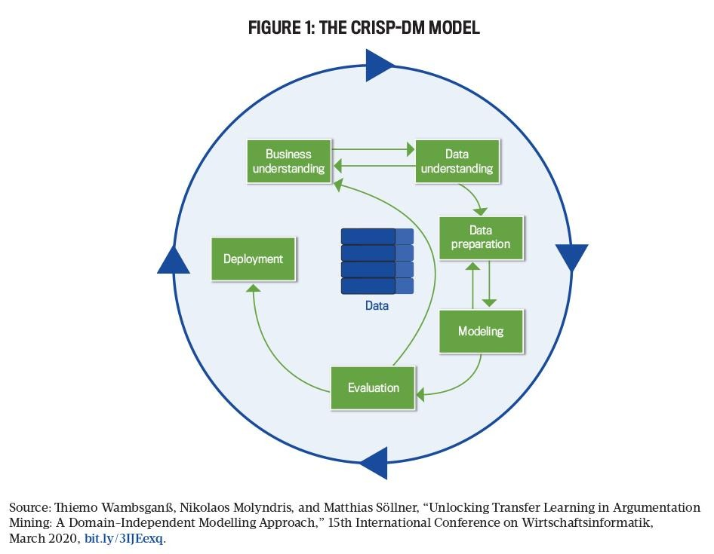
The first phase, business understanding, focuses on defining the objectives of the system from a user and organizational perspective. In this study, the primary goal is to address the challenge of information overload by delivering personalized and relevant news content. This aligns with research showing that users are increasingly overwhelmed by the volume of online information, necessitating intelligent filtering systems [24], [25].
The data understanding phase involves collecting and exploring datasets related to user interactions and news content. This includes analyzing user clicks, reading duration, and content categories to identify behavioral patterns. Such insights are critical for building adaptive models that can learn user preferences effectively [2].
Following this, the data preparation phase ensures that raw data is cleaned, transformed, and structured appropriately. This step is crucial in machine learning systems, as poor data quality can significantly affect model performance. Techniques such as normalization, feature extraction, and encoding are applied to prepare the dataset for modeling [27].
In the modeling phase, reinforcement learning techniques are implemented to enable the system to learn dynamically from user interactions. The system continuously updates its recommendation strategy based on rewards derived from user engagement, such as clicks and reading time. This approach has been shown to outperform static recommendation models in dynamic environments [6], [7].
The evaluation phase assesses the effectiveness of the model using performance metrics such as accuracy, precision, and user engagement rates. The system is tested to ensure that it meets the defined objectives and delivers meaningful recommendations. Finally, the deployment phase involves integrating the system into a user-facing platform, allowing real-time interaction and continuous learning.

3.3 Requirements Specification
Requirements specification is a critical process that defines the expected functionality and constraints of the system. It ensures that all stakeholders share a common understanding of what the system is intended to achieve. This process involves identifying stakeholders, gathering requirements, analyzing them, and validating their feasibility.
3.3.1 Stakeholder Identification
Stakeholders are individuals or groups with an interest in the system. In this project, the primary stakeholders include end users who interact with the recommendation system, system administrators responsible for maintenance, developers who design and implement the system, and content providers who supply news data. Each stakeholder group plays a significant role in shaping the system requirements and ensuring its success.
3.3.2 Requirements Gathering
Requirements were gathered using multiple techniques to ensure completeness and accuracy. A comprehensive literature review was conducted to understand existing systems and identify their limitations. Additionally, user surveys and informal interviews were used to capture user expectations and preferences. Observational studies of existing news platforms further provided insights into user behavior and interaction patterns. These methods collectively ensured that the system requirements are both user-centered and technically feasible [28].
3.3.3 Requirements Analysis
The gathered requirements were analyzed to ensure consistency, feasibility, and alignment with project objectives. This process involved organizing requirements into meaningful categories and identifying dependencies among system components. The analysis also helped prioritize critical features such as personalization and adaptability, which are central to the system’s success. Proper requirements analysis reduces ambiguity and ensures a clear roadmap for system development [28].
3.3.4 Functional and Non-Functional Requirements
The functional requirements define the core operations of the system. The system is expected to collect user interaction data, analyze behavioral patterns, and generate personalized recommendations. It must also allow users to interact with recommended content and continuously adapt based on feedback. Administrative functionalities are included to enable system monitoring and management.
Non-functional requirements focus on system performance and quality attributes. The system must provide real-time recommendations with minimal latency, ensuring a seamless user experience. It should also be scalable to accommodate increasing numbers of users and data. Security is another critical requirement, as user data must be protected against unauthorized access. Additionally, the system should be reliable and easy to maintain, allowing future enhancements without significant disruption [29].

3.4 Requirements Validation
Requirements validation ensures that the identified requirements accurately reflect user needs and are feasible within the project constraints. This process involved presenting the requirements to stakeholders for review and incorporating their feedback. Prototyping techniques were also used to provide a visual representation of the system, allowing users to evaluate its functionality before full implementation.
Consistency checks were performed to eliminate conflicting requirements, while feasibility analysis ensured that all requirements could be implemented using available resources and technologies. This step is essential in preventing costly errors during later stages of development and ensuring that the final system meets its intended objectives [28].

3.5 Summary
This chapter has presented the methodology used in developing the reinforcement learning-based adaptive recommendation system. The CRISP-DM framework was adopted due to its suitability for data-driven and machine learning applications. The chapter also detailed the requirements engineering process, including stakeholder identification, requirements gathering, analysis, and validation.
Furthermore, the system architecture was introduced, highlighting the key components and their interactions in delivering personalized recommendations. The structured approach outlined in this chapter ensures that the system is robust, scalable, and capable of adapting to user behavior. The next chapter will focus on the design and implementation of the system.

CHAPTER 4: SYSTEM DESIGN AND DEVELOPMENT
4.1 Introduction
Chapter Three established the CRISP-DM based methodology and requirements engineering process that underpin this project. Building on the functional and non-functional requirements identified in Section 3.3.4, this chapter presents the detailed design of the proposed Reinforcement Learning-based Adaptive News Recommendation Engine. It translates the requirements into a concrete architecture, illustrating how the system's components are structured and how they interact to deliver personalized, continuously adapting news recommendations. In addition to presenting this design, the chapter reports the development work undertaken to realise it as a working prototype, and states plainly, in each section, the extent to which each component has been designed, implemented, or evaluated at the time of writing.
The chapter is organised as follows. Section 4.2 presents the overall architectural design of the system. Section 4.3 discusses the software design, including the tools used for modelling and the detailed design of individual components, expressed through a set of complementary diagrams: a use case model, a sequence diagram, an activity diagram, and a data model. Section 4.4 presents the database design that underpins the system's data layer. Sections 4.5 to 4.7 describe how the frontend, backend, and recommendation engine have been designed and implemented. Section 4.8 presents the design of the reinforcement-learning model at the core of the recommendation engine. Section 4.9 describes the user-interaction and feedback mechanism and reports the evaluation carried out to date. Sections 4.10 and 4.11 describe the news data flow and the overall system workflow. Section 4.12 reports the development environment and current verification status, Section 4.13 summarises the technology stack actually used, and Section 4.14 summarises the chapter.
4.2 Architectural Design
The system adopts a layered client-server architecture, which separates concerns between presentation, application logic, intelligent decision-making, and data persistence. This separation is consistent with the non-functional requirements for scalability, maintainability, and security identified in Section 3.3.4, and it allows the reinforcement learning component to evolve independently of the user-facing frontend and the underlying data store [28].
As illustrated in Figure 4.1, the architecture comprises four layers. The Client Layer consists of a web-based frontend through which readers browse news content, view personalised recommendations, and implicitly express preference through their interactions (clicks, dwell time, and skips). The Application Layer exposes a REST API Gateway [30] that mediates all communication between the client and the backend services, and which delegates authentication, article retrieval, and interaction logging to dedicated services. The Intelligence Layer contains the RL Recommendation Engine itself: a contextual-bandit-based policy model [10] that selects which articles to present, a reward calculator that converts observed user behaviour into a learning signal, and a policy store that persists the current state of the model between requests. The Data Layer consists of a relational database that stores user profiles, article metadata, interaction logs, and recommendation history, and it is fed by an external news ingestion process that imports articles from third-party news sources and APIs.
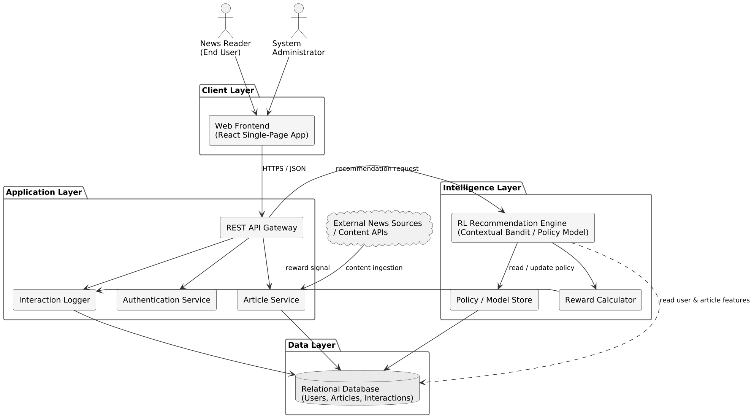

Figure 4.1: Proposed System Architecture

This architecture directly supports the adaptive behaviour central to the study's objectives (Section 1.3). Because the RL Recommendation Engine sits behind a well-defined internal interface (a recommendation request in, a ranked list of articles out; an interaction event in, an updated policy out), it can be retrained, replaced, or A/B tested without requiring changes to the client application. Likewise, because the frontend communicates only through the REST API Gateway, the existing web frontend prototype developed for this project can be reused with minimal modification, satisfying the constraint (Section 1.5) that the system's scope focuses on the recommendation engine rather than a rebuild of the user interface. This architecture has been realised in the implemented prototype described in Sections 4.5 to 4.7, which follows the layer boundaries described here without material deviation.
4.3 Software Design
4.3.1 Software Design Tools
The design artefacts presented in this chapter were produced using standard software modelling notations (Unified Modelling Language use case, sequence, and activity diagrams, and entity-relationship notation for the data model) so that the design remains tool-agnostic and can be verified against established software engineering practice [28]. The following tools are proposed to support the design and subsequent development of the system:
Category | Proposed Tool(s) | Purpose
Modelling / Diagramming | PlantUML / UML diagramming tools | Producing architecture, use case, sequence, activity, and data model diagrams
Backend Language & Framework | Python 3, Flask or FastAPI | Implementing the REST API Gateway and application services
Machine Learning / RL | scikit-learn, PyTorch, Gymnasium | Implementing and simulating the contextual bandit / RL policy model
Database | PostgreSQL (relational) | Persisting users, articles, interactions, and recommendation logs
Frontend | React (existing prototype) | Presenting the news feed and personalised recommendations to users
Version Control | Git | Source code management and change tracking
API Documentation / Testing | Postman / OpenAPI (Swagger) | Specifying and testing REST API endpoints

These tools are consistent with the Python-centred technology direction already established in Section 1.5 and Chapter 3, and they are widely adopted in both academic and industry recommender-system implementations, which reduces implementation risk for a final-year project of this scope.
4.3.2 Component Design
This section presents the detailed component-level design of the system using four complementary views: a use case model describing functional interactions between actors and the system; a sequence diagram describing the run-time flow of a single recommendation-and-feedback cycle; an activity diagram describing the continuous learning loop that is the core contribution of this project; and a data model describing the information persisted by the system. Together, these views were selected because each addresses a different design concern (behaviour, interaction, process, and data) without duplicating the others, in line with the requirement in Step 8 of the project brief that every diagram serve a distinct, well-defined purpose.
4.3.2.1 Use Case Model
Figure 4.2 presents the use case model for the system. Three actors interact with the system: the Reader (the primary end user), the System Administrator (responsible for content sources, user accounts, and system monitoring), and the RL Recommendation Engine itself, modelled as an actor because it autonomously generates recommendations and updates its policy independently of direct human instruction, consistent with its role as an adaptive, continuously learning component (Section 1.1).
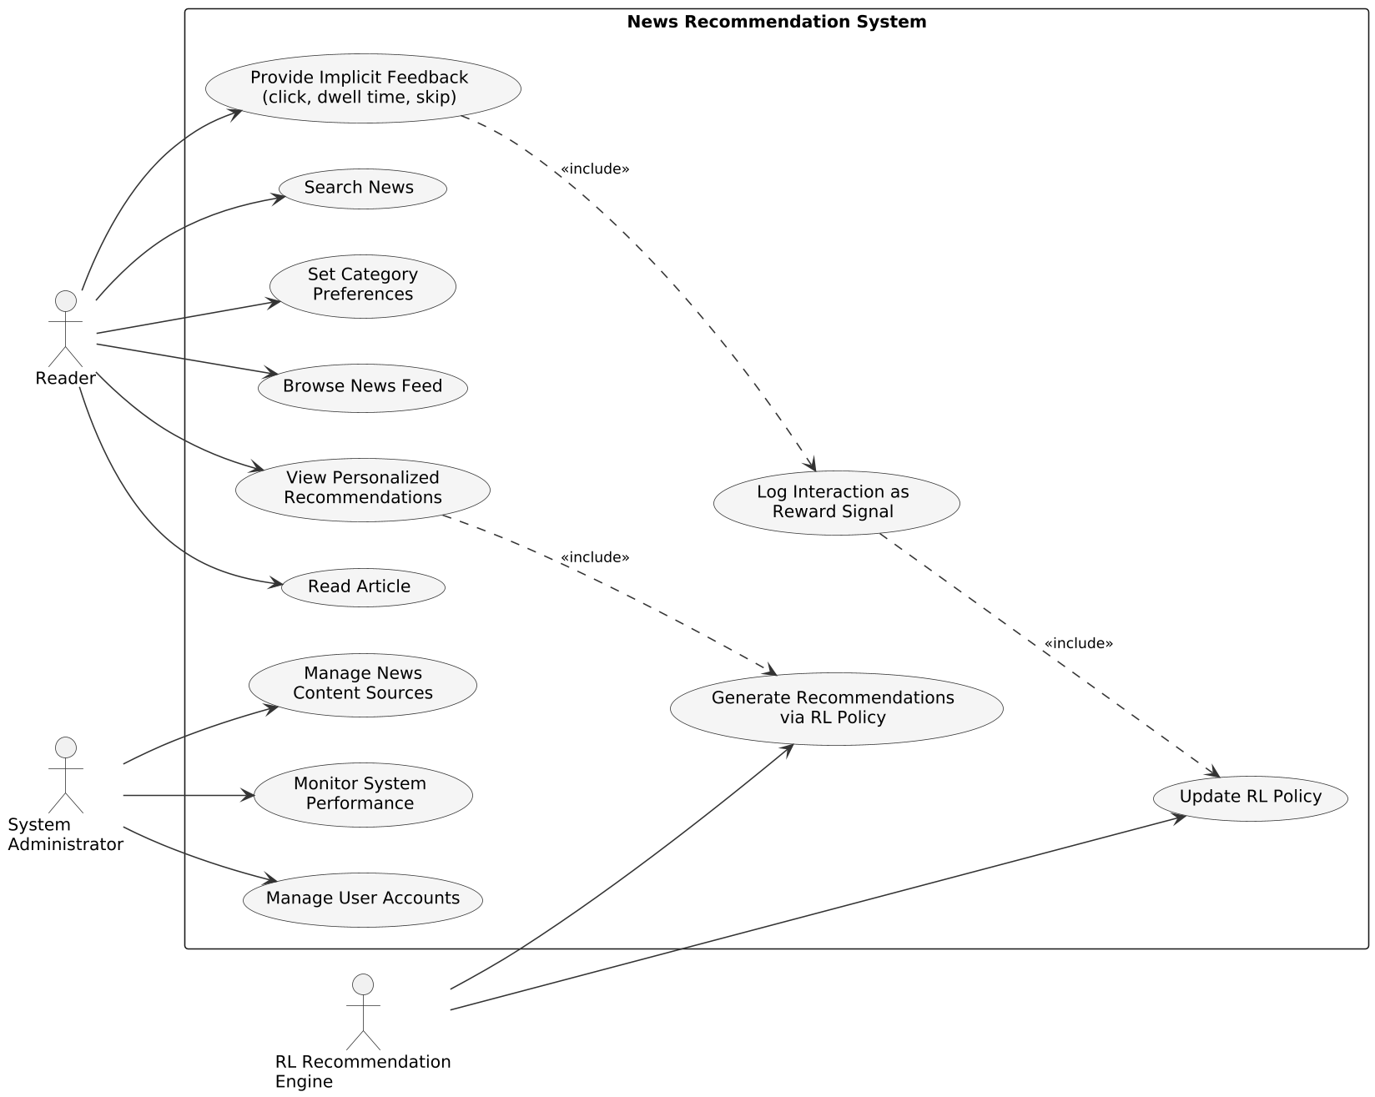

Figure 4.2: Use Case Diagram

The core reader-facing use cases are Browse News Feed, View Personalised Recommendations, Read Article, Search News, and Set Category Preferences. Provide Implicit Feedback is triggered whenever a reader clicks, reads, or skips an article, and it includes Log Interaction as Reward Signal, which in turn includes Update RL Policy: this include-relationship chain captures the closed-loop nature of the system, where every reader interaction ultimately feeds back into the model that generated the recommendation. View Personalised Recommendations includes Generate Recommendations via RL Policy, reflecting that recommendations are never static but are computed on demand from the current policy. Administrator-facing use cases (Manage News Content Sources, Monitor System Performance, and Manage User Accounts) support the operational, non-learning aspects of the system identified as functional requirements in Section 3.3.4.
4.3.2.2 Sequence Diagram
Figure 4.3 illustrates the run-time interaction sequence for a single recommendation-and-feedback cycle, involving the Reader, the Web Frontend, the API Gateway, the RL Recommendation Engine, and the Database.
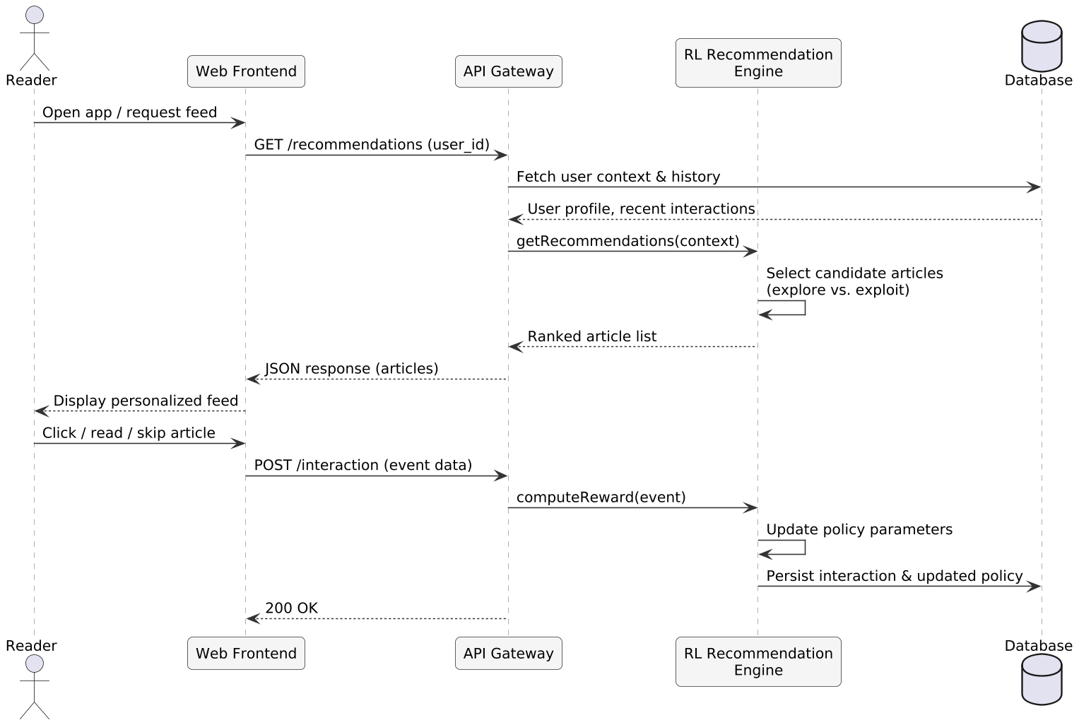

Figure 4.3: Sequence Diagram of the Recommendation and Feedback Cycle

When a reader opens the application, the frontend requests a personalised feed from the API Gateway, which first retrieves the reader's context (profile and recent interaction history) from the database. This context is passed to the RL Recommendation Engine, which selects a ranked list of candidate articles by balancing exploitation of known preferences against exploration of new or diverse content (Section 2.4). The ranked list is returned to the frontend and displayed to the reader. When the reader subsequently clicks, reads, or skips an article, the frontend reports this interaction event back to the API Gateway, which forwards it to the RL Recommendation Engine to compute a reward signal and update the policy parameters; the interaction and the updated policy state are then persisted to the database. This sequence repeats for every recommendation served, which is what allows the system to adapt within and across sessions rather than relying on a fixed, pre-trained model.
4.3.2.3 Activity Diagram
Whereas the sequence diagram describes a single request-response cycle between components, Figure 4.4 describes the continuous decision-feedback process from the perspective of the recommendation workflow itself, which is the central mechanism through which the system achieves adaptability (Research Question 2, Section 1.4).
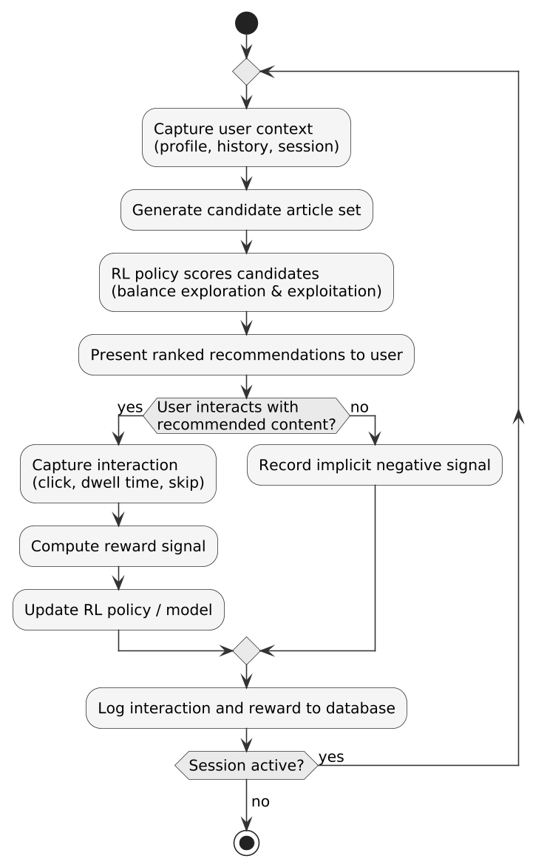

Figure 4.4: Activity Diagram of the Continuous Recommendation-Feedback Loop

The workflow begins by capturing the reader's current context, generating a set of candidate articles, and using the RL policy to score and rank them while balancing exploration and exploitation (Section 1.2). If the reader interacts with the recommended content, the interaction is captured, a reward is computed, and the policy is updated accordingly; if not, this is treated as an implicit negative signal. In either case, the event is logged to the database, and the loop repeats for as long as the session remains active. This design ensures that the model is never static: every recommendation served is itself an opportunity to learn, directly addressing the exploration-exploitation dilemma and the delayed-adaptation problem identified in Section 1.2.
4.3.2.4 Data Model (Entity-Relationship Diagram)
Because the proposed system is fundamentally data-driven, rather than object-oriented in the traditional sense, its structural design is expressed as an entity-relationship diagram (Figure 4.5) rather than a UML class diagram. This choice keeps the structural design aligned with the CRISP-DM data understanding and data preparation phases discussed in Section 3.2, and it maps directly onto the relational database design presented in Section 4.4.
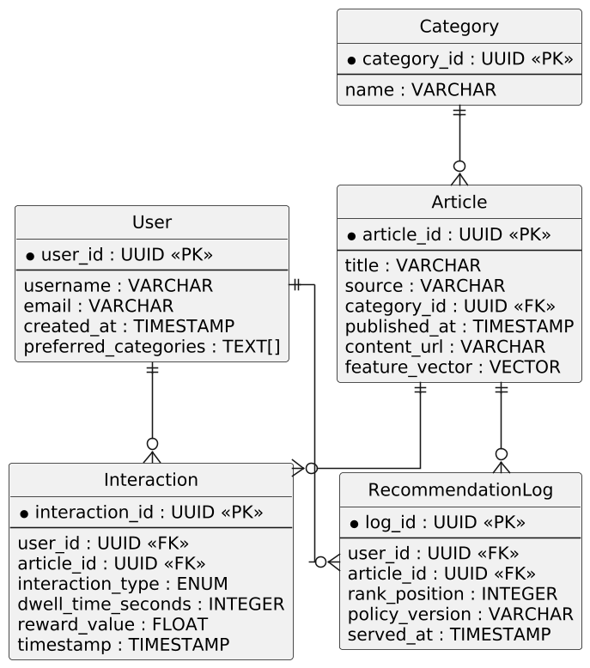

Figure 4.5: Entity-Relationship Diagram

Five core entities are identified. A User has many Interactions and appears in many RecommendationLog entries. An Article belongs to one Category, has many Interactions, and appears in many RecommendationLog entries. Interaction records capture the reward-relevant behaviour (interaction type, dwell time, and computed reward value) that drives policy updates, while RecommendationLog records what was actually shown to a user, in what order, and under which policy version, which is essential for the evaluation methodology described in Section 4.9.
4.4 Database Design
Table 4.1 summarises the relational schema derived from the entity-relationship diagram in Figure 4.5, which has been implemented against a PostgreSQL database using the schema-migration tool identified in Section 4.6. A relational database was selected over a purely document-oriented store because the relationships between users, articles, and interactions are well-defined and benefit from referential integrity, while individual fields such as article feature vectors can still be stored as structured columns or offloaded to a companion vector store if retrieval performance requires it during implementation.
Entity | Key Fields | Description
User | user_id (PK), username, email, created_at, preferred_categories | Registered readers of the platform
Category | category_id (PK), name | News categories (e.g., politics, sport, technology)
Article | article_id (PK), title, source, category_id (FK), published_at, content_url, feature_vector | News articles ingested from content sources
Interaction | interaction_id (PK), user_id (FK), article_id (FK), interaction_type, dwell_time_seconds, reward_value, timestamp | Recorded user behaviour, used to compute reward signals
RecommendationLog | log_id (PK), user_id (FK), article_id (FK), rank_position, policy_version, served_at | Record of what was recommended, when, and under which policy version

The RecommendationLog table exists independently of the Interaction table so that non-interactions (articles shown but not clicked) remain visible for evaluation purposes; without this record, it would be impossible to distinguish "not recommended" from "recommended but ignored," both of which carry different implications for the reward function described in Section 4.8. The policy_version field on both RecommendationLog and the Policy/Model Store (Figure 4.1) supports reproducibility, allowing recommendations to be traced back to the specific model state that produced them, which is a prerequisite for the evaluation methodology described in Section 4.9.
4.5 Frontend Design and Implementation
The Client Layer described in Section 4.2 has been implemented, rather than merely proposed, as a single-page application built with React 18, bootstrapped using Vite and styled with Tailwind CSS, with client-side navigation handled by React Router. This combination was chosen for its short development cycle and its common use in comparable recommendation-system prototypes reported in the literature [38], and it underlies the working frontend through which a reader actually interacts with the system.
Four principal views have been implemented and exercised during development. A registration and login view consumes the authentication endpoints described in Section 4.6 and stores the resulting access token for subsequent requests. A personalised news-feed view requests a ranked list of articles from the recommendation endpoint and renders it as a scrollable list of article cards, each showing the headline, source, category and publication time. An article-detail view displays the full article content and records the reader's dwell time and click-through, which are subsequently logged as interaction events (Section 4.9). A lightweight administrative view allows the seeded categories, articles and interaction records to be inspected directly from the browser, which was used repeatedly during the manual verification activity reported in Section 4.12.
Client-side state, including the authenticated user's session and the currently displayed feed, is managed using React's built-in hooks and context API rather than a dedicated state-management library; this was judged sufficient given the current scope of the prototype. Visual polish beyond functional usability, and an automated frontend test suite, have not yet been undertaken and are identified as further work rather than claimed as complete.
4.6 Backend Design and Implementation
The Application Layer has been implemented in Python 3 using the Flask framework, exposing a REST API whose endpoint groups correspond directly to the component boundaries shown in Figure 4.1. SQLAlchemy is used as the object-relational mapper translating the entities of Figure 4.5 and Table 4.1 into PostgreSQL tables, and Flask-Migrate, built on Alembic, manages schema migrations. The migration command (flask db upgrade) has been executed successfully against a live PostgreSQL instance, creating the tables summarised in Table 4.1; this is reported as work that has actually been carried out and verified, not as a planned step.
Authentication is implemented using Flask-JWT-Extended, which issues a signed access token on successful login and requires that token on all endpoints that read or write reader-specific data, including the recommendation and interaction-logging endpoints. An administrator account was created directly against the seeded database to support the manual verification activity described in Section 4.12, and the seeding scripts populated the database with an initial set of news categories, articles and, as described in Section 4.9, a body of synthetic interaction records used for offline evaluation in the absence of a live user base.
The API is organised into four endpoint groups: authentication (registration, login, token refresh); article management (listing and retrieving seeded articles by category); recommendations (invoking the recommendation engine described in Section 4.7 for the authenticated reader's current context); and interactions (recording click, skip and dwell-time events). The interactions endpoint is the point at which reader feedback enters the system, both for immediate display purposes and as the raw material from which the reward signal used in reinforcement-learning training (Section 4.8) is subsequently computed.
4.7 Recommendation Engine Design and Implementation
The recommendation engine sits at the boundary between the backend and the reinforcement-learning model. On each request it assembles a feature vector describing the requesting reader's current context from recent interaction history, passes that vector to the trained policy loaded through Stable-Baselines3 [36], and returns the resulting ranked list of candidate articles to the backend for delivery to the frontend. The engine has been implemented as a self-contained module so that the trained policy can be substituted with a random baseline or an oracle policy for the comparative evaluation reported in Section 4.9.
During manual testing of the implemented system with a newly created reader account possessing no interaction history, a defect was identified in which the recommended feed collapsed onto a single news category rather than presenting a varied set of articles. Inspection of the recommendation logs for that account traced the cause to the policy's near-deterministic action selection: for a cold-start context vector, corresponding to a reader with no recorded history, the policy consistently favoured the category that had received the greatest exposure during training. This behaviour was corrected by introducing epsilon-greedy exploration at inference time, together with a diversity-floor allocation rule guaranteeing that a minimum number of distinct categories appear in every served feed, an approach consistent with established exploration strategies for bandit-style recommendation problems [41], [42]. Re-inspection of the recommendation logs for the same test account after the fix confirmed that the collapse no longer occurred and that the feed presented articles drawn from multiple categories.
This account is included as part of the honest record of development requested for this chapter: the defect was a genuine engineering problem encountered while building the prototype, and its resolution, rather than a defect-free first implementation, is what is being reported. The specific values used for the exploration rate and the diversity floor were set empirically during this testing rather than through a systematic hyperparameter search, and tuning them more rigorously is identified as further work.
4.8 Reinforcement Learning Model Design
The recommendation problem is formalised as a sequential decision process within a custom environment built on the Gymnasium interface [37]. The observation space encodes the requesting reader's recent interaction history and contextual features of the candidate articles; the action space corresponds to the selection of an article, or a small ranked set of articles, from the available candidates; and the reward function, referenced from Section 4.4, assigns a numerical value to each recommendation based on the reader's subsequent feedback, principally click-through and dwell time, with skips contributing a low or negative reward. The Proximal Policy Optimization algorithm [35], as implemented in Stable-Baselines3 [36], is used to train the policy against this environment.
The initial version of the environment used single-step episodes, in which each episode consisted of exactly one recommendation decision before resetting, an arrangement intended to approximate the contextual-bandit formulation established by Li et al. [34] for personalised article recommendation. In this configuration, however, training logs showed negligible improvement in reward over time: with an episode terminating after a single step, the observed context carried little informative signal for the policy to learn from. The environment was consequently redesigned so that each episode represents a simulated reader session of approximately twenty sequential recommendation rounds, during which the reader's context evolves as interactions accumulate, while the discounting and reward structure retain the effectively contextual-bandit character of the problem, in line with related applications of reinforcement learning and contextual bandits to news recommendation [38], [39], [40]. This redesign, and the defect that motivated it, are reported here as part of the honest account of development this chapter is required to give, rather than presented as though the final design had been correct from the outset.
Following the redesign, the PPO agent was trained for 150,000 timesteps against the session-based environment. Training logs recorded the mean episode reward rising from approximately 4 at the start of training to approximately 8 by its conclusion, indicating that the policy was learning a measurably better recommendation strategy than its untrained starting point. This training run, and the log evidence it produced, are real and reproducible outputs of work already carried out on the prototype, not projected or assumed results.
The reward function itself combines an engagement component, weighted toward click-through and dwell time, with the exploration and diversity mechanisms described in Section 4.7, so that the trained policy is encouraged to balance exploitation of known reader preferences against continued exploration of under-represented categories. The theoretical grounding for this exploration-exploitation balance follows standard treatments of the multi-armed and contextual bandit problem [41], [42], applied here within the fuller sequential formulation described above.
4.9 User Interaction, Feedback Mechanism, and Evaluation
Reader feedback is captured through the Interaction and RecommendationLog tables introduced in the entity-relationship design of Section 4.3.2.4 and summarised in Table 4.1. Every recommendation served to a reader is written to the RecommendationLog table regardless of whether the reader subsequently acts on it, while clicks, dwell time and explicit skips are written to the Interaction table; together these two tables allow both positive and negative feedback to be reconstructed, which is essential for computing the reward signal described in Section 4.8.
Because the prototype has not yet been exposed to a live user base, a synthetic interaction dataset of 948 rows was generated using a scripted behaviour simulator and seeded into the database to provide the volume of feedback data needed to train and evaluate the recommendation policy. This dataset is explicitly synthetic, produced to exercise the pipeline end to end and to support the offline evaluation described below, and it is not presented as evidence of real reader behaviour.
Using this synthetic interaction data, an offline evaluation was carried out comparing three policies over held-out simulated sessions: a random baseline policy, which achieved a mean reward of approximately 0.20 per recommendation; the trained PPO policy described in Section 4.8, which achieved a mean reward of approximately 0.35 to 0.39; and an oracle policy representing an upper bound obtained by always selecting the highest-reward action available in a given context, which achieved a mean reward of approximately 0.57. This comparison indicates that the trained policy performs substantially better than random recommendation and recovers a meaningful proportion of the reward achievable under the oracle upper bound, and constitutes initial, genuine evidence toward the third research objective concerning the effectiveness of the adaptive recommendation approach.
This evaluation is deliberately reported within its actual scope. Standard recommender-system metrics such as Precision@K, Recall@K and NDCG@K, computed against an established benchmark dataset such as MIND [32], have not yet been computed, nor has the trained policy been compared directly against content-based or collaborative-filtering baselines. No live user study has been conducted, and consequently no engagement, diversity or adaptability measurements from real readers currently exist. These items are identified explicitly as necessary further work before the third research objective can be considered fully addressed, rather than being implied to have already been completed.
4.10 News and Current-Affairs Data Flow
At the time of writing, the system's article content is drawn from a bundled dataset of Zambian and international news and current-affairs articles that was prepared and seeded directly into the PostgreSQL database, together with the category taxonomy against which articles are classified, rather than from a live third-party news application programming interface. Each article record stores a headline, source, category, publication timestamp and body content, matching the Article and Category entities described in Section 4.3.2.4.
When a reader requests their feed, the backend retrieves candidate articles from this seeded dataset, the recommendation engine ranks them according to the process described in Section 4.7, and the frontend renders the resulting list. Integration with a live news application programming interface to provide continuously updated Zambian and international current-affairs content has been designed at the level of the architecture in Figure 4.1, in that the Application Layer is structured to accommodate an additional ingestion component without altering the layers above or below it, but this integration has not yet been implemented and is identified as future work distinguishing the present offline dataset from an eventual live feed.
4.11 System Workflow
The overall workflow implemented in the prototype begins when a reader logs in and receives a signed access token from the authentication endpoint. On requesting their feed, the frontend calls the recommendations endpoint, which in turn invokes the recommendation engine described in Section 4.7; the engine consults the trained policy together with the exploration and diversity mechanisms and returns a ranked list of articles, which the backend forwards to the frontend for display. As the reader clicks, skips or spends time on individual articles, the frontend reports these events to the interactions endpoint, which writes them to the Interaction and RecommendationLog tables described in Section 4.9. The accumulated interaction data is subsequently used, in an offline training run rather than a continuous online loop at the present stage of development, to retrain and re-evaluate the policy as described in Section 4.8.
This workflow corresponds directly to the sequence diagram in Figure 4.3 and the activity diagram in Figure 4.4 presented in Section 4.3.2; both diagrams have been confirmed, through the manual end-to-end testing summarised in Section 4.12, to describe the behaviour that the implemented prototype actually exhibits, rather than a workflow that remains only on paper.
4.12 Development Environment and Verification Status
Development and testing of the prototype have been carried out on a Windows-based development machine, using Python 3 for the backend and reinforcement-learning components and Node.js for the frontend build tooling, against a locally installed PostgreSQL server. The database schema was created by executing the Flask-Migrate upgrade command, and the resulting tables were populated using seeding scripts that inserted the initial categories and articles described in Section 4.10, an administrator account, and the 948 synthetic interaction records described in Section 4.9. The presence and structure of these tables, and the row counts inserted by the seeding scripts, were confirmed by direct inspection of the running database using the psql command-line client.
Verification of the prototype's behaviour has, at this stage, been conducted manually rather than through an automated test suite: the frontend flows described in Section 4.5 were exercised by hand, the database state was checked directly as described above, and the reinforcement-learning training and evaluation runs described in Sections 4.8 and 4.9 were inspected through their logged output. No unit or integration test suite has yet been written for either the backend or the frontend, and constructing one is identified plainly as further work rather than claimed to already exist.
The prototype currently runs only on the development machine described above. Containerised packaging or deployment to a cloud environment has not been attempted, consistent with the scope of a final-year prototype set out in Section 1.5, and remains a target for work beyond the present dissertation.
4.13 Technology Stack
Table 4.2 consolidates the technologies actually used to build the prototype described in this chapter, organised by the architectural layer introduced in Section 4.2. It is presented separately from the design-tool listing in Section 4.3.1 to distinguish the modelling tools used to produce the diagrams in this chapter from the technologies used to implement the running system itself.
Layer / Component | Technology | Role in the Implemented System
Client Layer | React 18, Vite, Tailwind CSS | Single-page frontend application; implemented and running (Section 4.5)
Client Layer | React Router | Client-side navigation between feed, article, and authentication views
Application Layer | Python 3, Flask | REST API implementing the endpoint groups described in Section 4.6
Application Layer | SQLAlchemy, Flask-Migrate (Alembic) | Object-relational mapping and schema migration; flask db upgrade executed against PostgreSQL
Application Layer | Flask-JWT-Extended | Token-based authentication for protected endpoints
Data Layer | PostgreSQL | Relational data store implementing the schema in Table 4.1
RL / Recommendation Layer | Gymnasium [37] | Custom environment formalising the recommendation problem (Section 4.8)
RL / Recommendation Layer | Stable-Baselines3, PPO [35], [36] | Training algorithm and implementation for the recommendation policy
RL / Recommendation Layer | NumPy, pandas, scikit-learn | Feature computation, synthetic interaction simulation, offline evaluation (Section 4.9)
Data Ingestion | Bundled offline article dataset | Current source of seeded news and current-affairs content (Section 4.10); live API integration is future work
Tooling | Git | Version control of source code throughout development

Every entry in Table 4.2 corresponds to a technology that has been installed, configured and exercised during development, as opposed to one considered only as an alternative during design; where a tool was evaluated but not adopted, that consideration is confined to the discussion in Section 4.3.1 and is not repeated here.
4.14 Chapter Summary
This chapter has presented both the design and the development progress achieved on the Reinforcement Learning-based Adaptive News Recommendation Engine. It described the layered system architecture, the software design artefacts produced during modelling, and the database design, before reporting, layer by layer, how the frontend, backend, recommendation engine and reinforcement-learning model have actually been built, including two genuine engineering defects encountered during development and the fixes applied to resolve them. It further reported the user-interaction and feedback mechanism, the flow of news and current-affairs data through the system, the end-to-end system workflow, the development environment in which the prototype was built and verified, and the technology stack actually in use.
Considered against the three research objectives set out in Chapter 1, the chapter contributes as follows. The first objective, analysing the limitations of existing recommendation approaches, is addressed principally in Chapter 2 and is reflected in the design decisions justified throughout this chapter, particularly the exploration and diversity mechanisms adopted to mitigate the filter-bubble effect discussed in the literature [21]. The second objective, designing and developing an adaptive reinforcement-learning-based recommendation model, has been substantially addressed: the model has been designed, implemented and trained, with reproducible evidence of learning reported in Section 4.8. The third objective, evaluating the effectiveness of the proposed system in terms of accuracy, engagement, diversity and adaptability, has been partially addressed through the offline comparison against random and oracle baselines reported in Section 4.9; the standard benchmark metrics, baseline comparisons and live user evaluation still required to consider this objective fully met have been identified explicitly rather than assumed, and constitute the principal remaining work beyond the scope of this dissertation.
References
[1] H. Zhao, X. Qian, and C. Li, “Deep Reinforcement Learning for List-wise Recommendations,” IEEE Transactions on Knowledge and Data Engineering, vol. 34, no. 5, pp. 2341–2353, 2022.

[2] Y. Gao, F. Liu, and J. Zhao, “Deep Reinforcement Learning for News Recommendation with User Behavior Modeling,” Information Processing & Management, vol. 60, no. 1, 2023.

[3] L. Chen, P. Zhang, and Q. He, “Reinforcement Learning-Based Recommender Systems: A Survey,” ACM Computing Surveys, vol. 55, no. 6, pp. 1–38, 2023.

[4] X. Wang, Y. Zhang, and M. Wang, “Dynamic Recommendation with User Preference Drift Using Reinforcement Learning,” IEEE Access, vol. 10, pp. 11234–11245, 2022.

[5] S. Zheng, H. Liu, and J. Tang, “DRN: A Deep Reinforcement Learning Framework for News Recommendation,” in Proc. ACM SIGKDD, 2022, pp. 167–176.

[6] Z. A. Anderson and B. Kuipers, “Personalized Recommendation via Reinforcement Learning: A Review and Future Directions,” IEEE Transactions on Neural Networks and Learning Systems, vol. 34, no. 2, pp. 567–580, 2023.

[7] M. Ie, V. Mnih, and K. Kavukcuoglu, “Reinforcement Learning for Slate-Based Recommender Systems,” in Proc. International Conference on Machine Learning (ICML), 2022.

[8] J. Zou, Y. Chen, and L. Xie, “Context-Aware News Recommendation Using Deep Reinforcement Learning,” Expert Systems with Applications, vol. 213, 2023.

[9] R. S. Sutton and A. G. Barto, Reinforcement Learning: An Introduction, 2nd ed., MIT Press, 2022.

[10] X. Liu, Y. Li, and Z. Sun, “Sequential Recommendation with Reinforcement Learning: Recent Advances and Challenges,” IEEE Transactions on Big Data, vol. 10, no. 1, pp. 45–60, 2024.

[11] Y. Koren and R. Bell, “Advances in Collaborative Filtering Revisited,” ACM Computing Surveys, 2022.
[12] H. Chen et al., “Deep Learning for Recommender Systems: A Survey and New Perspectives,” ACM Transactions on Information Systems, 2023.
[13] S. Rendle et al., “Neural Collaborative Filtering Revisited,” IEEE Transactions on Knowledge and Data Engineering, 2022.
[14] L. Wu et al., “Graph Neural Networks in Recommender Systems: A Survey,” IEEE Transactions on Neural Networks, 2023.
[15] X. Wang et al., “Explainable Recommendation Systems: A Survey and New Directions,” ACM SIGKDD Explorations, 2022.
[16] H. Abdollahpouri et al., “Fairness in Recommender Systems: Research Trends and Challenges,” ACM Computing Surveys, 2023.
[17] S. Zhang et al., “Sequential Recommendation with Reinforcement Learning: A Survey,” IEEE Transactions on Big Data, 2024.
[18] M. Quadrana et al., “Sequence-Aware Recommender Systems,” ACM Computing Surveys, 2021.
[19] X. Liu et al., “Dynamic Recommendation Systems with User Preference Drift Modeling,” IEEE Access, 2024.
[20] Y. Gao et al., “News Recommendation Using Deep Reinforcement Learning and User Behavior Modeling,” Information Processing & Management, 2023.
[21] E. Pariser, The Filter Bubble: What the Internet Is Hiding from You. New York: Penguin Press, 2011.
[22] D. Bawden and L. Robinson, “The Dark Side of Information: Overload, Anxiety and Other Paradoxes and Pathologies,” Journal of Information Science, vol. 35, no. 2, pp. 180–191, 2009.
[23] M. J. Eppler and J. Mengis, “The Concept of Information Overload: A Review of Literature from Organization Science, Accounting, Marketing, MIS, and Related Disciplines,” The Information Society, vol. 20, no. 5, pp. 325–344, 2004.
[24] N. Newman, R. Fletcher, K. Eddy, C. T. Robertson, and R. K. Nielsen, “Digital News Report 2023,” Reuters Institute for the Study of Journalism, University of Oxford, 2023.
[25] Pew Research Center, “News Consumption Across Social Media in 2021,” Pew Research Center, Washington, D.C., Sept. 2021.
[26] P. Covington, J. Adams, and E. Sargin, “Deep Neural Networks for YouTube Recommendations,” in Proc. 10th ACM Conference on Recommender Systems (RecSys), 2016, pp. 191–198.
[27] P. Chapman et al., “CRISP-DM 1.0: Step-by-Step Data Mining Guide,” SPSS Inc., 2000.
[28] I. Sommerville, Software Engineering, 10th ed. Harlow: Pearson, 2015.
[29] ISO/IEC 25010:2011, Systems and Software Engineering — Systems and Software Quality Requirements and Evaluation (SQuaRE) — System and Software Quality Models. Geneva: International Organization for Standardization, 2011.
[30] R. T. Fielding, “Architectural Styles and the Design of Network-based Software Architectures,” Ph.D. dissertation, University of California, Irvine, 2000.
[31] C. D. Manning, P. Raghavan, and H. Schütze, Introduction to Information Retrieval. Cambridge: Cambridge University Press, 2008.
[32] F. Wu et al., “MIND: A Large-scale Dataset for News Recommendation,” in Proc. 58th Annual Meeting of the Association for Computational Linguistics (ACL), 2020.
[33] T. Wambsganß, N. Molyndris, and M. Söllner, “Unlocking Transfer Learning in Argumentation Mining: A Domain-Independent Modelling Approach,” in Proc. 15th International Conference on Wirtschaftsinformatik, Mar. 2020.
[34] L. Li, W. Chu, J. Langford, and R. E. Schapire, “A Contextual-Bandit Approach to Personalized News Article Recommendation,” in Proc. 19th Int. Conf. World Wide Web (WWW), Raleigh, NC, USA, 2010, pp. 661–670.
[35] J. Schulman, F. Wolski, P. Dhariwal, A. Radford, and O. Klimov, “Proximal Policy Optimization Algorithms,” arXiv:1707.06347, 2017.
[36] A. Raffin, A. Hill, A. Gleave, A. Kanervisto, M. Ernestus, and N. Dormann, “Stable-Baselines3: Reliable Reinforcement Learning Implementations,” Journal of Machine Learning Research, vol. 22, no. 268, pp. 1–8, 2021.
[37] M. Towers et al., “Gymnasium: A Standard Interface for Reinforcement Learning Environments,” arXiv:2407.17032, 2024.
[38] C. Wu, F. Wu, S. Ge, T. Qi, Y. Huang, and X. Xie, “Neural News Recommendation with Multi-Head Self-Attention,” in Proc. 2019 Conf. Empirical Methods in Natural Language Processing and 9th Int. Joint Conf. Natural Language Processing (EMNLP-IJCNLP), Hong Kong, China, 2019, pp. 6389–6394.
[39] G. Zheng, F. Zhang, Z. Zheng, Y. Xiang, N. J. Yuan, X. Xie, and Z. Li, “DRN: A Deep Reinforcement Learning Framework for News Recommendation,” in Proc. 2018 World Wide Web Conf. (WWW), Lyon, France, 2018, pp. 167–176.
[40] M. M. Afsar, T. Crump, and B. Far, “Reinforcement Learning Based Recommender Systems: A Survey,” ACM Computing Surveys, vol. 55, no. 7, pp. 1–38, 2023.
[41] T. Lattimore and C. Szepesvári, Bandit Algorithms. Cambridge, U.K.: Cambridge University Press, 2020.
[42] P. Auer, N. Cesa-Bianchi, and P. Fischer, “Finite-time Analysis of the Multiarmed Bandit Problem,” Machine Learning, vol. 47, pp. 235–256, 2002.

APPENDICES
Appendix A: Glossary of Terms
Term | Definition
Contextual Bandit | A simplified reinforcement learning setting in which an agent selects an action (here, an article) based on context, receives a reward, but does not model transitions between states, unlike full sequential RL [9].
Cold Start Problem | The difficulty a recommendation system faces in generating accurate recommendations for new users or new items with little or no historical interaction data.
Exploration-Exploitation Trade-off | The balance a reinforcement learning agent must strike between exploiting known, high-reward actions and exploring new actions that may yield higher reward [9].
Filter Bubble | A state in which a user is algorithmically exposed to a narrow range of viewpoints or content due to personalisation, limiting exposure to diverse perspectives [21].
NDCG (Normalised Discounted Cumulative Gain) | An information-retrieval metric that measures ranking quality, giving more credit to relevant results appearing earlier in a ranked list [31].
Policy (RL) | The strategy a reinforcement learning agent uses to select actions given a context or state.
Reward Signal | A numerical value fed back to a reinforcement learning agent indicating how favourable an outcome (e.g., a user interaction) was.

Appendix B: Supplementary Materials (To Be Added by the Researcher)
This appendix is reserved for supplementary materials that support the study but are not reproduced in the main body of the report, for example: any requirements-gathering instruments actually used (survey or interview questions, per Section 3.3.2), full system source code listings or a link to the project repository, complete evaluation result sets and plots from further, larger-scale evaluation beyond the prototype-level results reported in Chapter 4, and any ethical clearance or consent documentation associated with user data collection. These materials should be attached by the researcher once available; none are fabricated or assumed here.

